**MCSE – Level 1 Windows Easy Transfer Lab 2**

**Objective:**

Use Windows Easy Transfer to save user profiles between different operating systems.

**Scenario:**

Let’s assume a very small company has one Windows 7 computer. It has 3 employees who each have their own account on the computer. As the company grows it purchases a 2nd computer. This time it is a Windows 8 computer. Shortly after that, it purchases a 3rd computer which is a Windows 10 computer.

The 3 users on the Windows 7 computer will each have a computer now. It is time to transfer the user profiles to the computers belonging to the user. John Smith will remain on the Windows 7 computer. Mary White will be assigned to the Windows 8 computer, and Tom Elliot will get the Windows 10 computer.

**Procedure**

___ Create a Word document. Save it as ***lastname*_Lab2** where “lastname”

is your last name. For instance, Clairmont_Lab2.

___ Start Saskatoon, Hamilton and Ottawa in VMWare. Saskatoon is a Windows 10 machine, Ottawa is a Windows 7 machine and Hamilton is a Windows 8 machine.

**Ottawa (Windows 7)**

___ Log into Ottawa as the Administrator.

___ Create a new user called **John Smith**. To do this, click on the **Start** button and type **lusrmgr.msc**. Figure 1 should be visible.

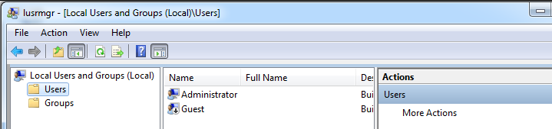

Fig. 1 Creating new users on Ottawa

___ Click on **Users**. Right-click on the right-hand pane and select **New User….**. The user name will be **Jsmith**. Use **P@ssw0rd** as the password. Use this password for all users created in this course. Check the box that says **password never expires**. Click on **Create**.

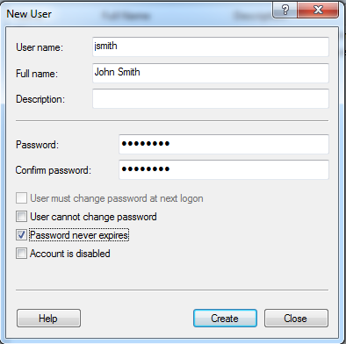

Fig. 2 Creating a new user called Jsmith

___ Create a 2nd user called **Mwhite**.

___ Create a 3rd user called **Telliot**.

**1. Capture the 3 new accounts.**

___ Create a folder in the root of C: called **SavedSettings**. When you run the WET program it will create a file that contains the 3 users’ profiles. We will store this file in the **SavedSettings** folder.

Let’s customize Jsmith’s desktop.

___ Log out of the Administrator’s account and log in as **Jsmith**.

___ Click on **Start**, **All Programs**, **Accessories** and add an icon to the desktop for **NotePad** and **Paint**. You must drag the two utilities from the **Accessories** folder to the desktop while holding the CTRL key.

___ Create two text documents in the **Documents** folder. Call the documents **Smith1.txt** and **Smith2.txt**. Put a line of text in each document so it is not an empty document. (You can create a text file by right-clicking on the folder area, select **new** and **Text Document**). See figure 3.

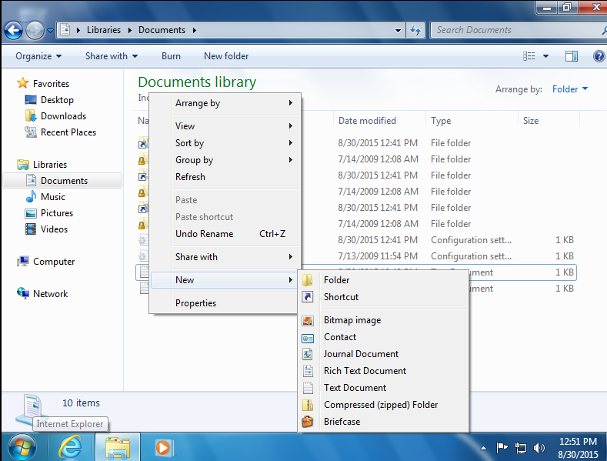

Fig. 3 Creating a text document in the **Documents** folder

___ Log out and log back in as **Mwhite**. Open the **Accessories** menu and add icons to the desktop for the command prompt and the calculator.

___ Create two text documents in the **Documents** folder. Call the documents **White1.txt** and **White2.txt**. Put a line of text in each document.

___ Log out of White’s account so the changes to the profile will be saved.

___ Log back in as **telliot**.

___ Open the **Accessories** menu and add icons to the desktop for the **WordPad** and the **Snipping Tool**.

___ Create two text documents in the **Documents** folder. Call the documents **Elliot1.txt** and **Elliot2.txt**. Put a line of text in each document.

___ Log out and log in as Jsmith. Open the **Documents** folder to reveal the two text documents. Click on **Start** so the **Jsmith** name is visible at the top of the Start menu.

**2. Capture the desktop showing the two text documents in the Documents folder, the NotePad and Paint icons and the start menu with Jsmith at the top. Your screen capture should look like**

**figure 4.**

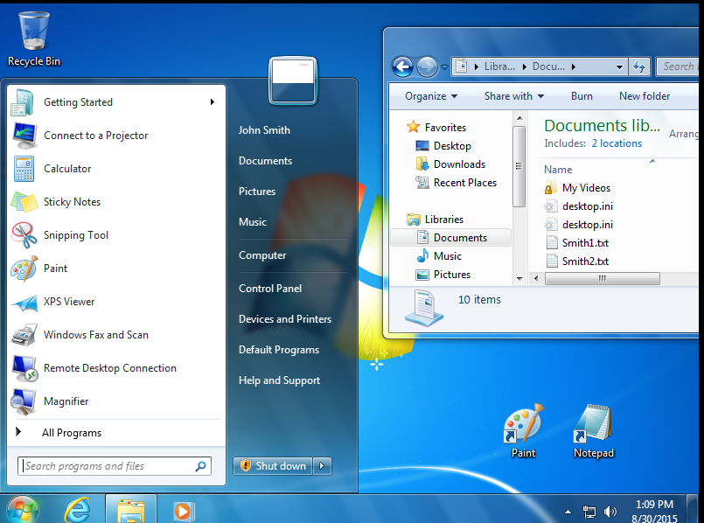

Fig. 4 jsmith’s desktop

Let’s use the WET program to save and then transfer the 3 user profiles to a

Windows 8 computer.

___ Log out and log back in as the Administrator. You must be the administrator to be able to run the WET program.

___ Click on the **Start** button and then type **Windows Easy Transfer**.

___ On the first screen click **Next**.

___ On the next screen, select **An external hard drive or USB flash drive**.

___ On the next screen, choose **This is the old computer**.

___ On the next screen, clear the check box opposite Administrator. We do not want to transfer the Administrator account. Click on **Next**.

___ On the next screen, do not bother supplying a password.

___ Save the file in the **SavedSettings** folder that you created earlier. Rename the file to **<lastname>.**MIG where lastname is your lastname.

**3. Capture the view in Windows Explorer showing the size of the file.**

We are going to have to transfer the WET file to Hamilton so we can extract the user profile for Mary White. We cannot transfer the file directly from Ottawa to Hamilton so we will copy the file to the root of C: on the physical hard drive.

___ While you still have the **SavedSettings** folder open on Ottawa, open the Windows Explorer on the host machine. This is shown in figure 5.

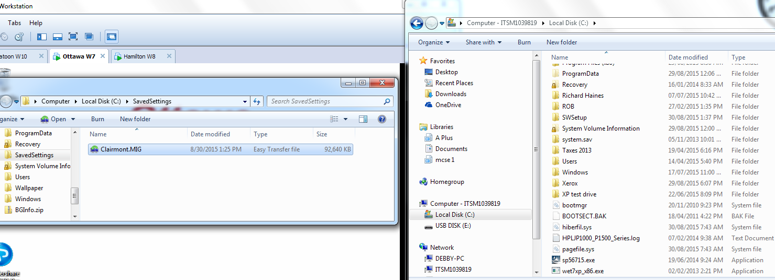

Fig. 5 Transferring the WET file from Ottawa to the host machine

___ Click and drag the WET file from Ottawa to the root of C:\ on the host machine.

**Hamilton (Windows 8)**

___ Log in as the Administrator.

___ If you are not at the **Start** screen, press the windows key (just to the left of the space bar. That will get you to the Start screen).

___ Click on the **Desktop** tile. Click on the folder in the task bar. Drag the

file created by WET from the Windows Explorer on the Windows 7 host computer to the root of C:\ on the Windows 8 computer.

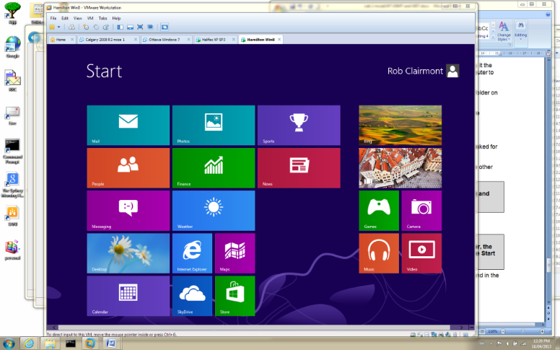

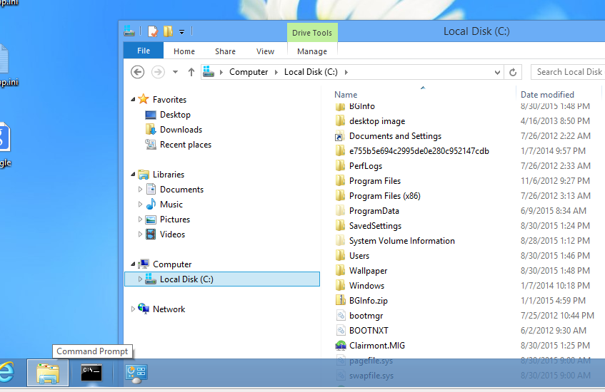

Fig. 6 Copying the file created by WET to the Windows 8 computer

___ Double-click on the file created by WET file on Hamilton. The WET program should start.

___ We only want to transfer mwhite so clear the check boxes on jsmith and telliot.

___ Click on **Transfer**.

___ When the transfer is complete expand the screens as shown in figure 6.

**4. Capture the view shown in figure 7.**

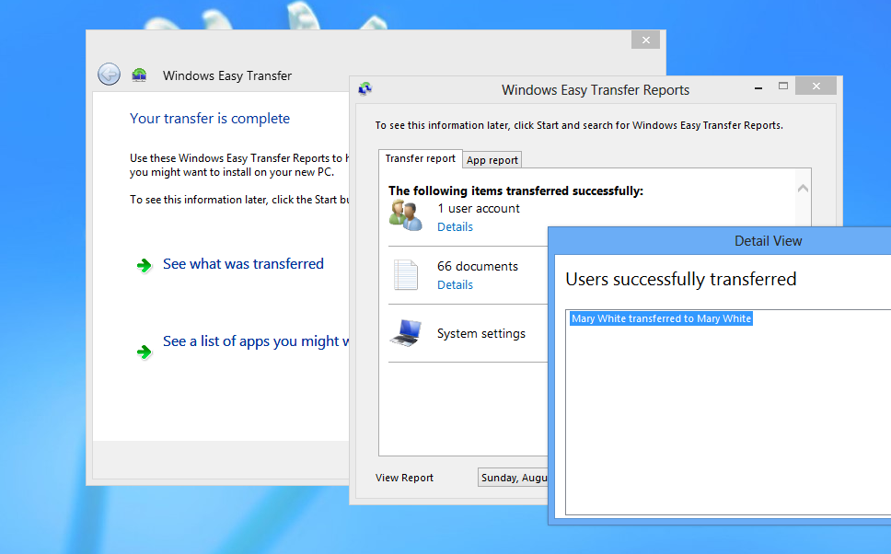

Fig. 7 Mary White account and profile has been copied to Hamilton

___ Close the WET program.

Let’s see what has happened. An account for mwhite should have been created and the profile for mwhite should appear on the hard drive.

___ Press the **windows-key** (to the left of the space bar) and at the same time press the R-key. This will open the **RUN** box.

___ Type **lusrmgr.msc**.

___ Click on the **Users** folder and **mwhite** should be visible in the right-hand pane.

**5. Capture contents of the “Users” folder showing the new account for mwhite.**

When the WET program creates the new account it has no idea what the password was on the original account found on the Windows 7 machine. You must change the password before mwhite can log in.

___ Right-click on mwhite in the right-hand pane and select **Set Password**.

___ Click on **Proceed** and supply the password **P@ssw0rd**.

Beside creating a new user account, the WET program should have created a profile for the user on the hard drive.

___ Click on the light-blue Desktop tile and open the Windows explorer. Expand drive C:\ and click on the **Users** folder.

___ A folder for **mwhite** should appear in the **Users** folder. Click on the **mwhite** folder so the contents is displayed in the right-hand pane.

This folder is the profile for **mwhite**.

**6. Capture the contents of the mwhite folder.**

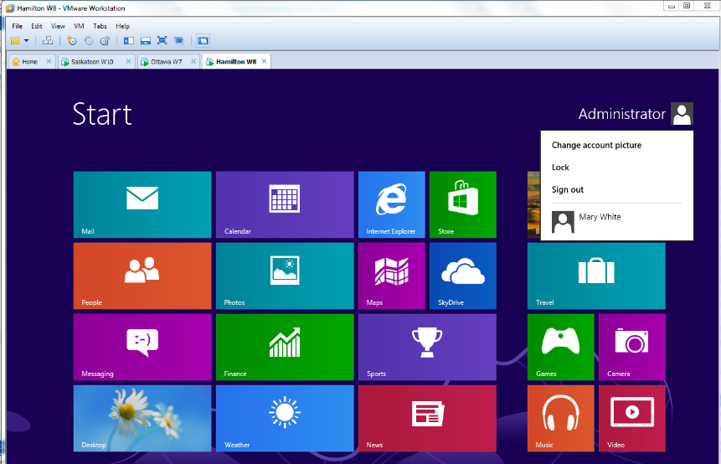

___ Press the Window key to get to the **Start** screen shown in figure 8.

___ Click on Administrator and **Sign out**.

___ Log in as mwhite.

___ Click on the **Desktop** tile. The calculator and command prompt tiles should be visible.

Fig. 8 Logging out of Windows 8

___ Expand the contents of the **Documents** folder in the Windows Explorer. The two mwhite files should be displayed.

___ Double-click on the command prompt icon. The prompt should contain the mwhite name.

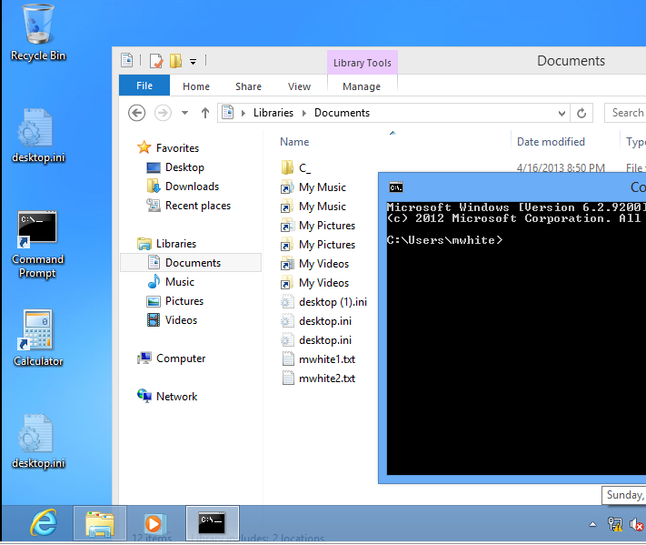

Fig. 9 Proof that the mwhite profile was copied to Hamilton by the WET program.

**7. Capture the same view shown in figure 9**

We still have to transfer **Telliot**’s account and profile to Saskatoon, the Windows 10 computer.

**Saskatoon (Windows 10)**

___ Log into Saskatoon as the Administrator.

___ Open the Windows Explorer; (click on **Start** and select **File Explorer**).

___ Open the Explorer on the host machine so both Explorers are visible as shown in figure 10.

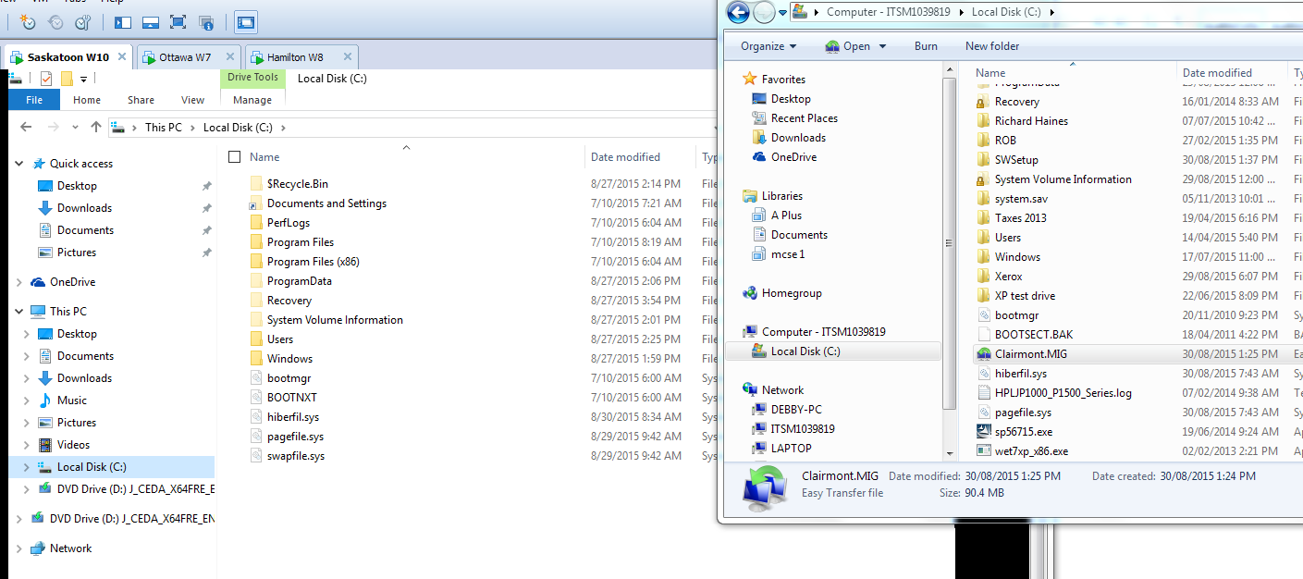

Fig. 10 The Explorer on Saskatoon and the Explorer on the host machine

___ Try dragging the file created by WET to the hard drive on Saskatoon.

The circle with a line through it does not change to a “+” sign indicating that you cannot drag the file from the host computer to Saskatoon. If you want to drag files between the host computer and virtual machines the virtual machines must be configured to allow it.

Both Ottawa and Hamilton were preconfigured by the instructor. Saskatoon will have to be configured by you.

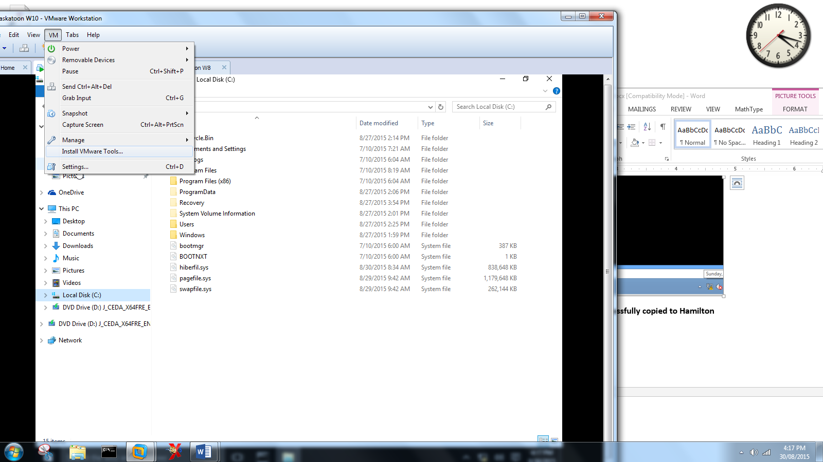

___ Click on the **VM** option and select **Install VMware Tools**.

___ In the Windows Explorer highlight drive D: and double- click on Setup64.exe.

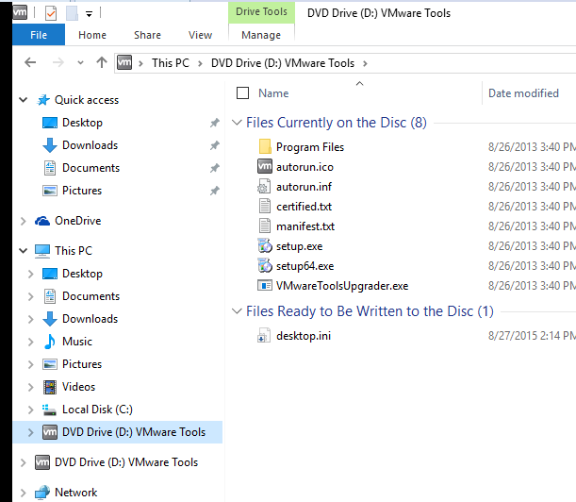

Fig. 11 Installing VMware tools on Saskatoon

___ Follow the screens supplied by the installation wizard. Do a “typical” installation.

___ Once the VMware tools are installed, restart the Saskatoon as requested.

___ Copy the file created by WET from the host computer to Saskatoon.

___ Double-click on the file you transferred.

Notice you are asked what program you want to use to run the WET file. Windows 10 does not recognize the .MIG file. As mentioned in the lecture, WET has been dropped from Windows 10.

There is a work-around for this problem. Windows 7 keeps its WET program in the Migwiz folder located in the C:\windows\system32 folder.

___ Open the C:\windows\system32 folder on the Windows 7 host computer.

___ Drag the migwiz folder to the root of C: on Saskatoon.

___ Run the **migwiz64.exe** program from the migwiz folder on Saskatoon.

___ Follow the wizard’s screens to transfer the profile for **telliot**.

___ Once the **telliot** account is transferred, press the Window-key and the

R-key at the same time to open the Run box. Type **lusrmgr.msc**.

___ Display the contents of the Users folder showing **telliot** now has an account on Saskatoon.

**8. Capture the contents of the Users folder showing telliot has an account.**

___ Reset the password on the telliot account.

___ Open the Windows Explorer and display the contents of the telliot profile.

**9. Capture the contents of the Users folder showing telliot has an profile.**

___ Log out of the administrator’s account and log in as telliot.

___ Open the Windows Explorer and display the contents of the Documents folder showing the two telliot.txt files are present.

___ Open a command prompt to show telliot is part of the prompt.

___ Position the command prompt, and the Windows Explorer so the two shortcuts are visible on the desktop as shown in figure 12.

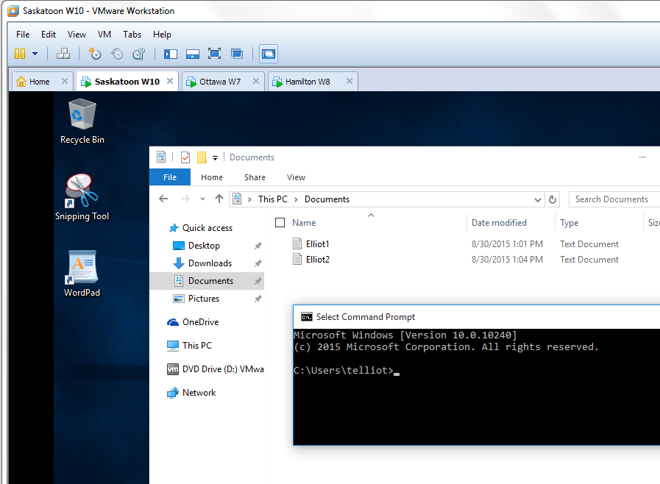

Fig. 12 Telliot’s profile has been restored on Saskatoon

**10. Capture Telliot’s desktop as shown in figure 12.**

___ Ok. We’re done. Shut down the 3 operating systems

[](http://www.google.ca/url?sa=i&rct=j&q=&esrc=s&frm=1&source=images&cd=&cad=rja&docid=2YxOGEPIHFDJDM&tbnid=wUNEfKeomI67GM:&ved=&url=http://joeblow.wordpress.com/2010/08/15/the-end-2/&ei=TJVtUZj4LYfrygH174DwBA&bvm=bv.45175338,d.aWc&psig=AFQjCNEDqS9WW_s5uDHXW_DypXurxsMmyg&ust=1366222540990538)

*That’s it folks !*

*Wrap her up!*